**DESIGN PATTERNS AND PRINCIPLES**

**Exercise 1: Implementing the Singleton Pattern:**

**Main.java:**

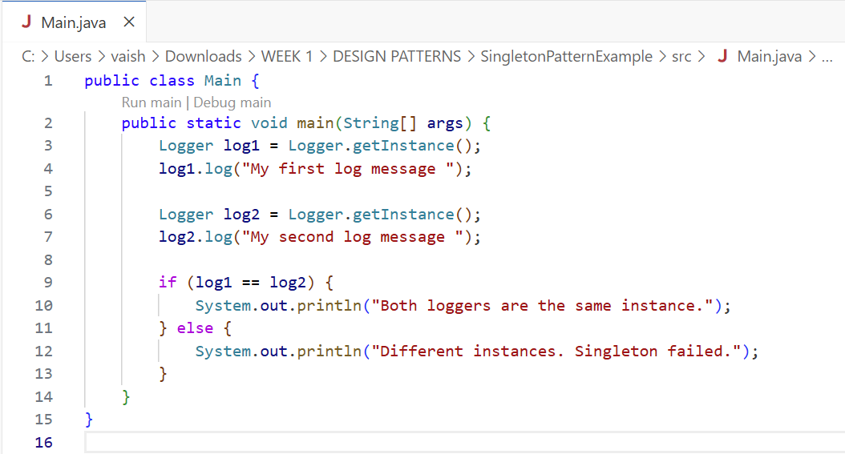

**Logger.java:**

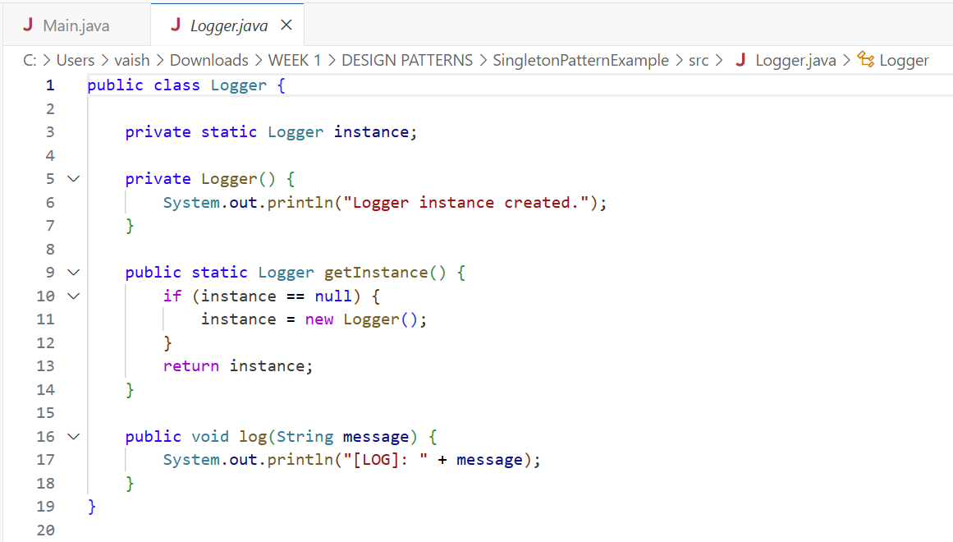

**OUTPUT:**

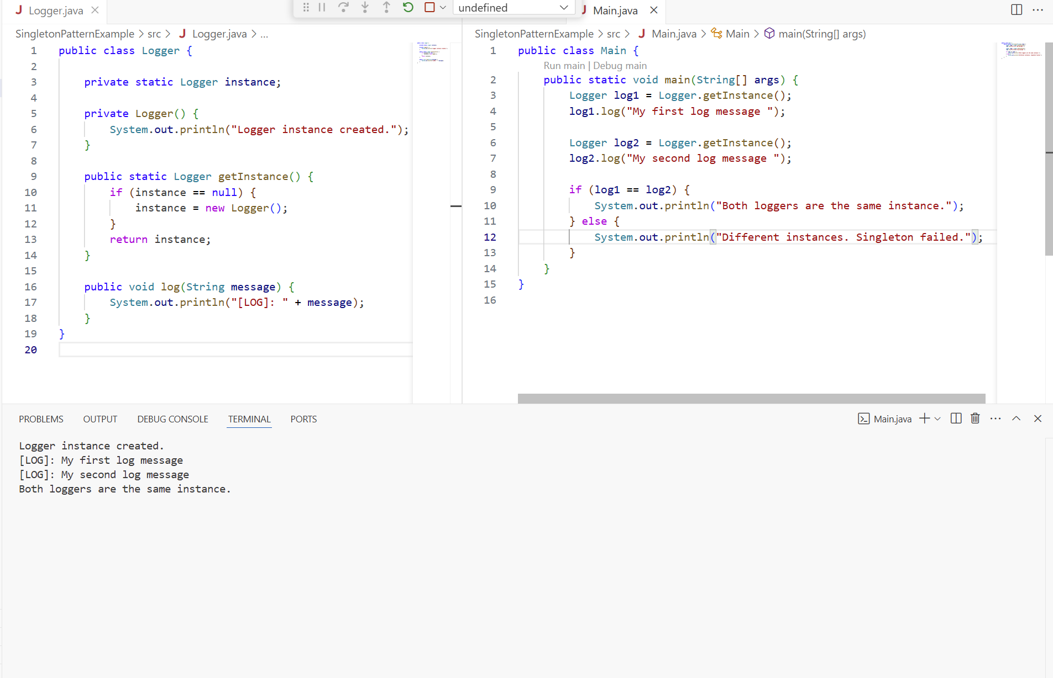

**Exercise 2: Implementing the Factory Method Pattern:**

**Document.java, DocumentFactory.java:**

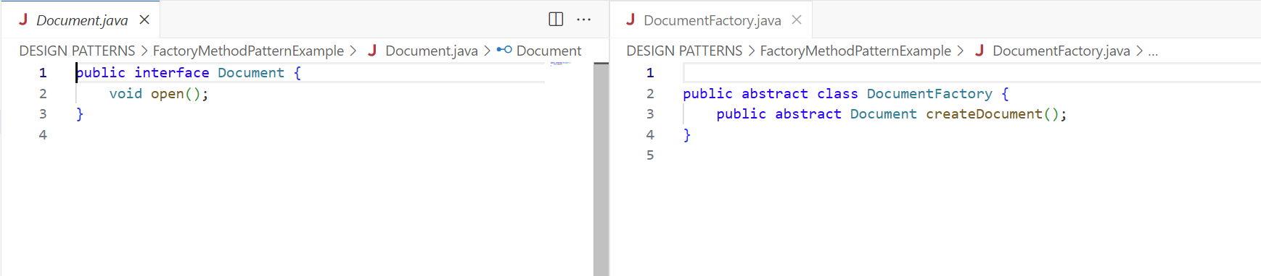

**ExcelDocument.java, ExcelDocumentFactory.java:**

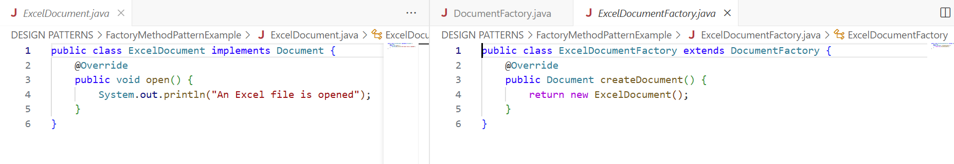

**PdfDocument.java, PdfDocumentFactory.java:**

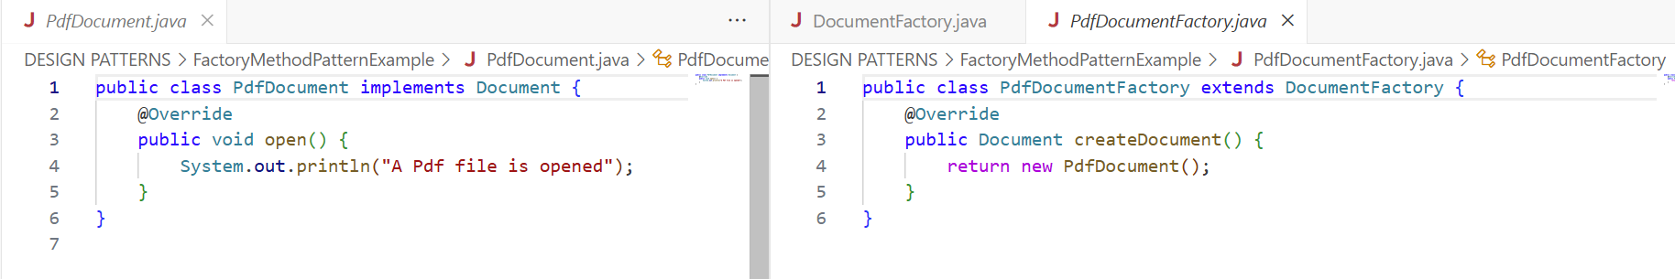

**WordDocument.java, WordDocumentFactory.java:**

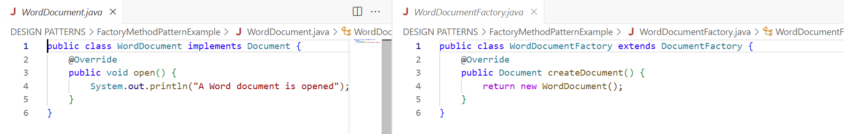

**Main.java:**

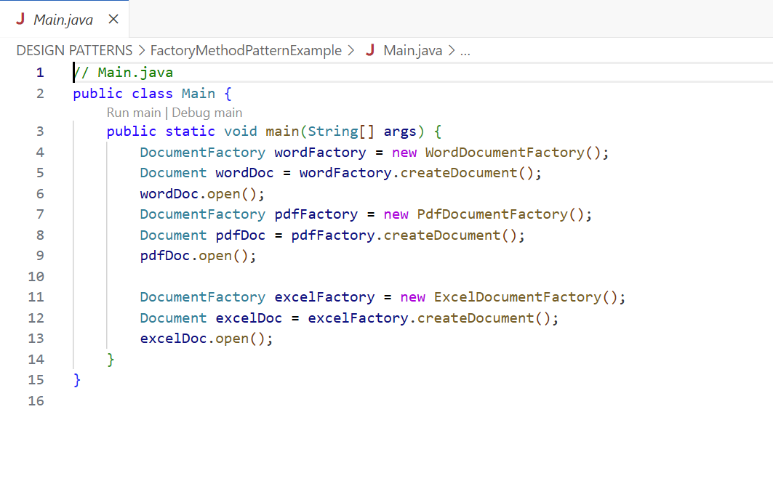

**OUTPUT:**

